Arica Conrad

BIT 465 – REST API Development

February 13, 2022

Assignment 4 - Building an App Using Django Rest Framework Backend and a React Frontend

Instructions

I have researched a tutorial that will take you through the processes involved in transforming a Django app into a REST API that can be consumed by a frontend. The tutorial can be found [here](https://wsvincent.com/django-rest-framework-react-tutorial/). Use this tutorial to build your first Django API. This tutorial uses a React framework. As part of the learning process, you might have to make some changes and/or Google some things to successfully complete this assignment.

Submission

Submit a Word document that contains the screenshots of the items listed on the grading rubric and a link to your GitHub repository for this assignment.

Link to My GitHub Repository

This is the link to the GitHub repository that contains my backend and frontend code:

<https://github.com/AricaLConrad/Assignment-4-Building-an-App-Using-Django-Rest-Framework-Backend-and-a-React-Frontend>

Part 1: Todo_Api

View that lists all the todo items:

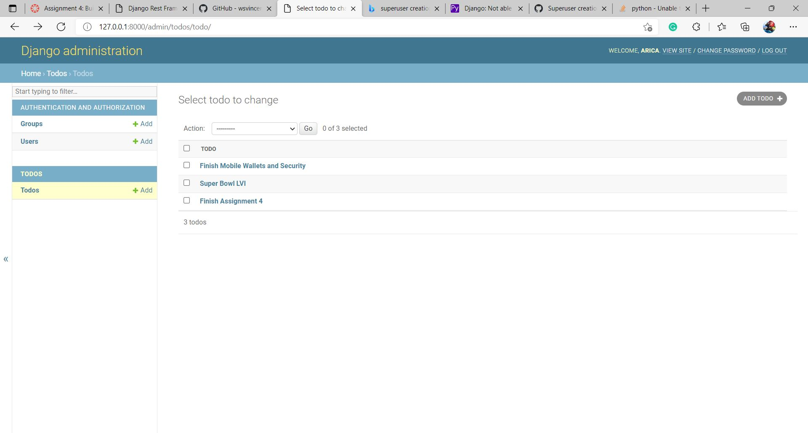

View that lists the details of one todo item:

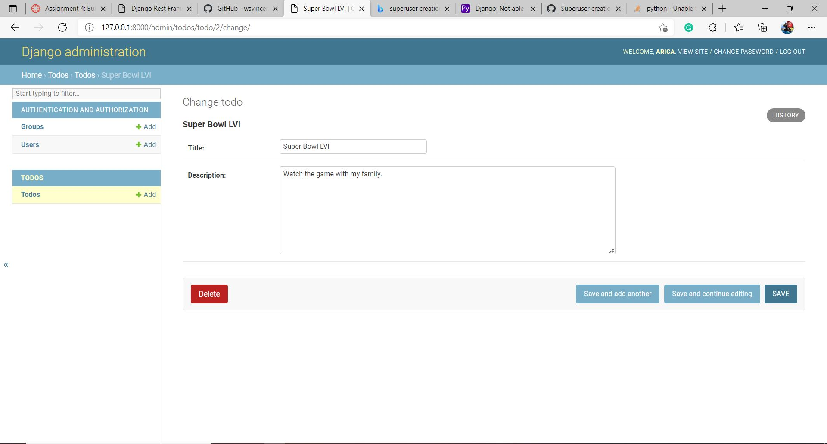

Part 2: Browsable API – List Todo

Viewing the todo list in the browsable API:

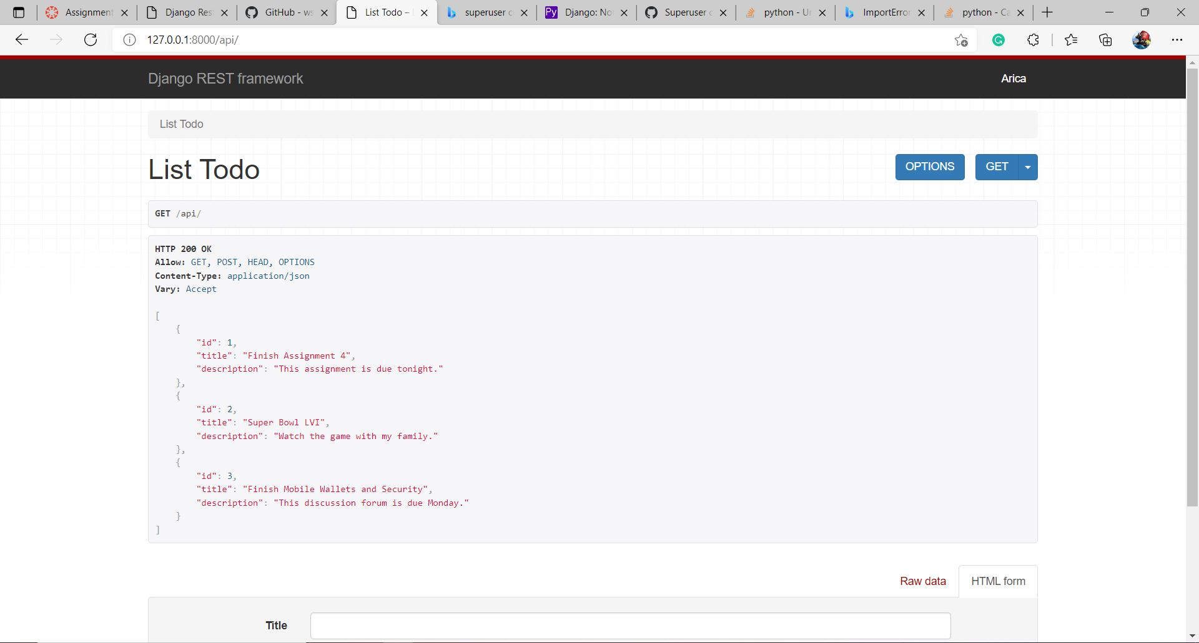

Part 3: Browsable API – Detail Todo

Viewing one todo list item in the browsable API:

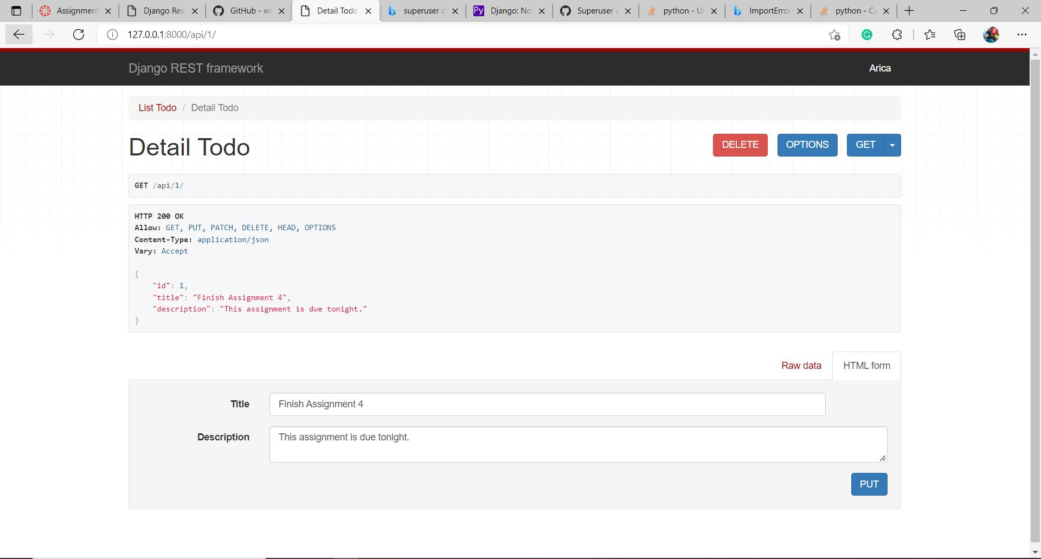

Part 4: Todo Front End

A React front end that consumed the todo list API:

